WINGS & WHEELS MODELERS MEMBERSHIP
First Name |  | Last name
Address |  | City | State
ZIP Code | Phone | E-mail
Membership runs 1 July through 30 June. New memberships at the contest run through June of the following year.
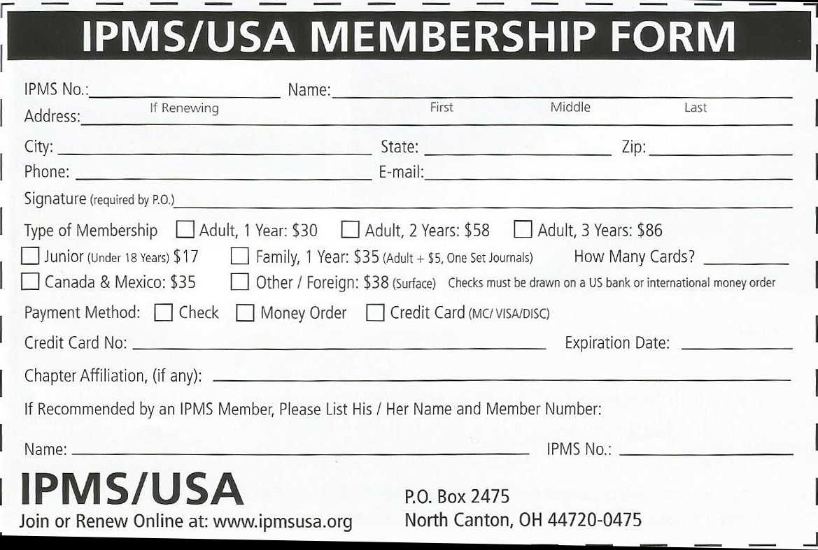
Wings & Wheels Membership (Required) |  | $15.00 | Method of payment
IPMS Membership (Optional) |  | $25.00 |  | Check
Total |  |  |  | Cash
Mail check (made out to Wings & Wheels Modelers) to
Al LaFleche, 167 Piper Rd. West Springfield MA 01089

